## Project Documentation for Northwest Tire Company

**Built and compiled by**



**For**



Table of Contents

Project Documentation for Northwestern Tires Company 1

Use Cases 4

User Specifications 5

Technical Requirements 25

Database Specifications 27

Introduction

The purpose of this document is to provide a high level overview of the new system built by Rincon Consulting Inc. for the express use by Northwest Tire Company owners and employees. It will provide both a brief explanation of each form that is available along with a picture what those forms look like. This is not intended to be a user’s manual but simply to provide a basic understanding of the system and familiarize users with the basic layout of the system.

The current computer system used at Northwest Tire was installed three years ago. It is a small Unisys minicomputer consisting of three terminals and a printer. Northwestern had a local software development firm create customized software for their use. The system consists of a payroll system, an accounts receivable (A/R) system, an accounts payable (A/P) system, and an inventory control and procurement system. To tie it all together, the system also maintains a general ledger and produces the necessary financial reports for tax purposes.

Rincon Consulting was called in to upgrade and overhaul the existing system, which includes a blending of paper based and computer based interaction. We determined a system needed to be built that would perform the following items.

* update inventory files at the time of a sale (retail or wholesale).
* Provide the ability for tire transfers between stores which would result in timely updates of the inventory file.
* Provide the ability to record tire sales by store/salesman/date/tire code.
* Provide warehouse personnel a way to check inventory files in order to determine if a dealer order can be filled. Thus eliminating the need to perform a physical “rack check” for existing inventory.
* Store personnel must have a way to check inventory files in order to determine if they can fill a customer order. If they can’t they need a way to check another store’s inventory to see if they can transfer a tire from store to store.
* Incoming tire shipments to the warehouse must result in a faster update to the inventory file. Warehouse personnel need to be able to update the inventory quickly and easily when shipments arrive, and to easily note which tires requested on a particular P.O. did not arrive.
* The process of determining when to reorder tires for the warehouse needs to be improved. The inventory of all the stores (not just the warehouse) should be used in determining which tires to order.

## Use Cases

|  |
| --- |
| User can logon to system with appropriate credentials. |
| Users logoff. |
| Users exit. |
| President/ Bookkeeper/Warehouse Manager/Store Manager/Salesman checks global inventory. |
| President/ Bookkeeper/Warehouse Manager/Store Manager/Salesman checks local store inventory. |
| President can add new tirecode. |
| President can maintain tirecode. |
| Warehouse Manager/Warehouse Personnel update inventory. |
| President/Bookkeeper can add employee. |
| President/Bookkeeper can maintain employee. |
| President can add new store. |
| President can maintain stores. |
| President/Bookkeeper/Warehouse Manager runs global inventory report. |
| Store Manager/Salesman creates a transfer. |
| Store Manager/Salesman creates retail sale and prints receipt. |
| President runs sales reports based on a date range. |
| End of class |
| Bookkeeper can close Dealer shipping order. |
| Global Inventory Report shows tires that need to be ordered. |
| President/Bookkeeper/Warehouse Manager/Store Manager runs store inventory reports. |
| Bookkeeper can close purchase order by receiving rest of inventory on PO. |
| Bookkeeper can close Dealer shipping order. |
| Warehouse Manager/Warehouse Personnel can update receiving. |
| Manager/Bookeeper can create manufacturer purchase order. |
| Bookkeeper can create Dealer shipping order. |
| Re-work Transfer screen to improve user functionality.  Warehouse Manager will have the Manager access as well as the ability to receive tires. |
| 3 click rule for application screens. |
| Center defined screens |
| camelCase notation as project default. |
| Global font Arial. |
| Global Cancel |

## User Specifications

1. **Splash Screen**

The first step in using the new software is to open the program. The first thing you will see is a splash screen (Figure A) which will disappear in a few seconds.

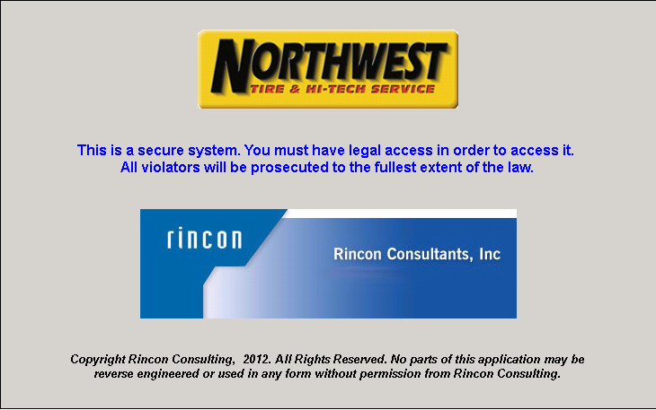

**(Figure A)**

1. **Login**

The next page displayed is the login screen and this is where you will enter you user name and password (Figure B). Your login and password will determine your clearance level determining what forms you can or cannot access. Please see you system administrator if you feel you do not have the correct access to the system.

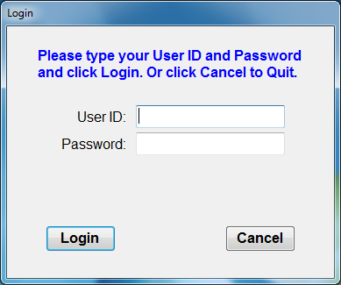

**(Figure B)**

1. **Main Menu**

Once login is completed you will see your Main Menu for the example below (Figure C) this it was the main menu will look like for someone with admin access.

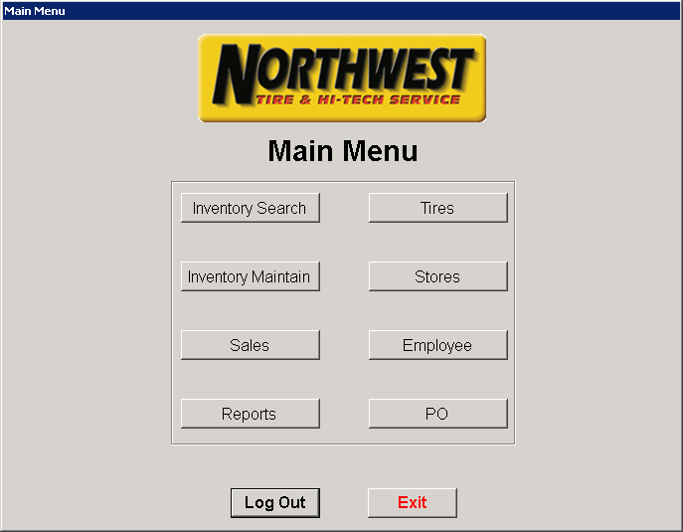

**(Figure C)**

If any of the buttons on the Main Menu (Figure C) are grayed out then your permission settings do not allow you access to that form. As stated before if you feel your access is not what you believe it should be please contact the system admin.

Access to the different forms is as follows:

**Sales:** Inventory Search & Sales

**Managers:** Inventory Sales, Inventory Maintain, Sales, & Reports

**Warehouse:** Inventory Search & Inventory Maintain

**Admin:** Access to everything

1. **Inventory Search**

If you choose the Inventory Search button it will open that screen (see Figure D). As you can see there are multiple options for searching for a tire. You can search by tire code, manufacture, description, and tire size.

If you wish to not use any of the above options you can leave the search box empty and move to the (Store Option) dropdown and simply choose a store number which will list everything that store has available. If you choose a store then search by tire code, manufacture, description, and tire size you will only see what that particular store has in stock.

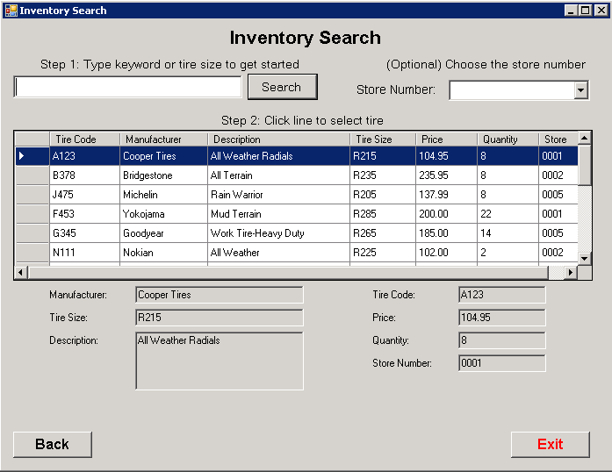

**(Figure D)**

1. **Inventory Maintain**

The next form is the Inventory Maintain (Figure E) which gives the managers the ability to maintain system vs. physical inventory per store. It also will allow the managers to perform store to store transfers when needed (See Figure F).

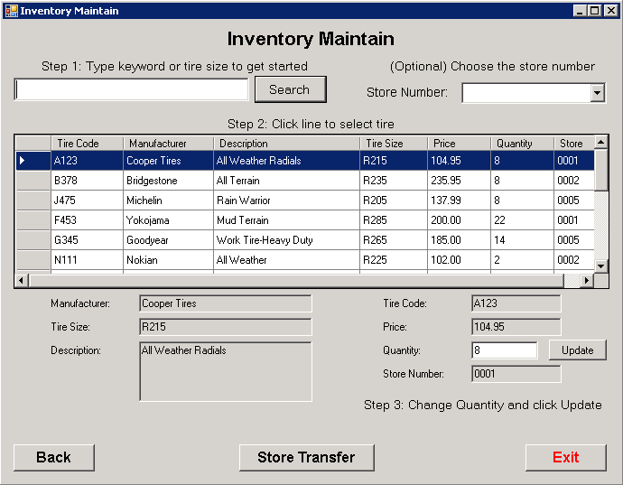

**(Figure E)**

To access the form that allows you to transfer from store to store simply press the “Store Transfer” button at the bottom of the “Inventory Maintain” form (Figure E).

1. **Store Transfer**

In the stores transfer form you will choose the store your shipping from and which store to deliver to. You will fill out the tire code and quantity you want transferred before pushing the “Transfer Inventory” button.

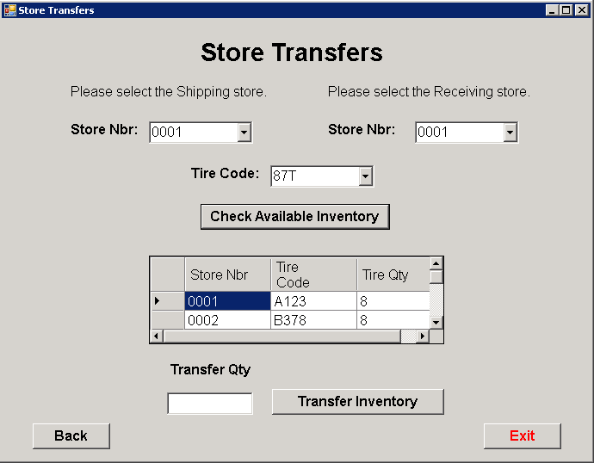

**(Figure F)**

1. **Sales**

In (Figure G) you will see what the sales form looks like for both managers and sales people. This form only allows them the ability to process sales for customers.

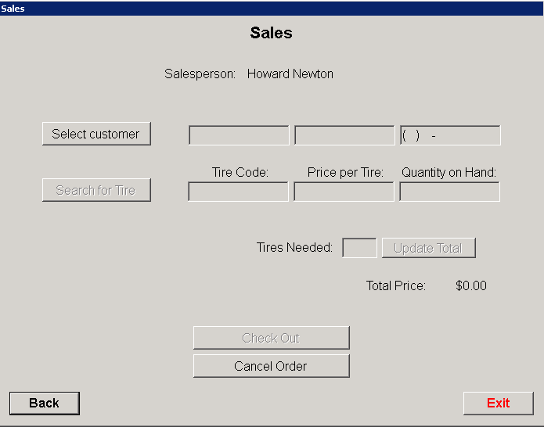

**(Figure G)**

From the main sales screen (Figure G) you will choose the “Select Customer” button and it will take you to (Figure H) where you can choose from an existing customer, create a new customer, or edit an existing customer.

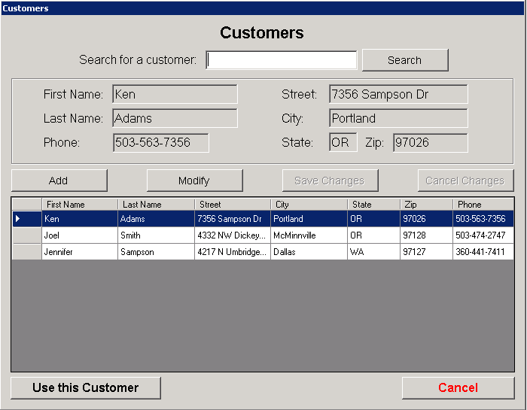

**(Figure H)**

Once sales has chosen or added the customer they want you push the “Use this Customer” button. This takes you back to the Sales form (Figure G) and populates the customer information and activates the “Search for Tire” button (Figure I).

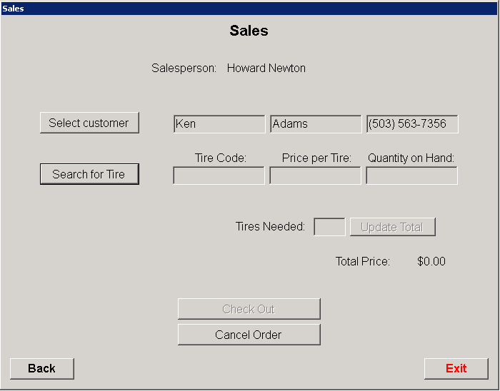

**(Figure I)**

You then can access the “Tire Inventory Search” form which allows you to search by store or tire code, manufacture, description, and tire size or both store and tire. Once you see the tire you want simply click on the grey box next to the tire code you want. The row will be highlighted and push the “Select this Tire” button (Figure J).

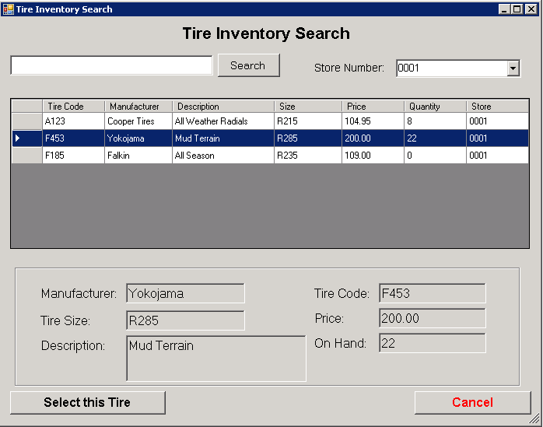

**(Figure J)**

After selecting both the customer and tire they want you will be back on the “Sales” form and just need to enter how many tires the customer wants. Push the update total button which in turn will update your total price for the tires and activate the “Check Out” button (Figure K).

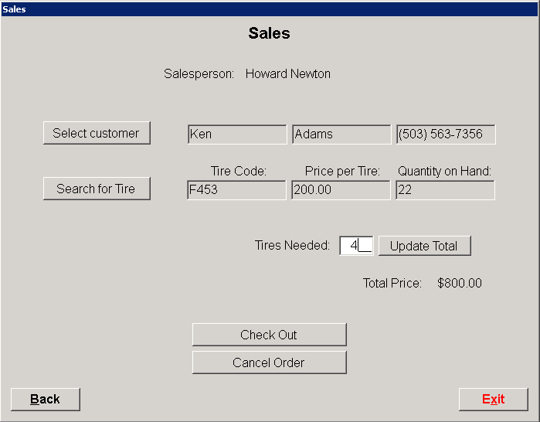

**(Figure K)**

If you have admin access to the Sales form it will allow you to not only perform sales to customer but dealers as well. As you can see in (Figure L) you have access to the “Dealer Orders” button at the bottom of the screen.

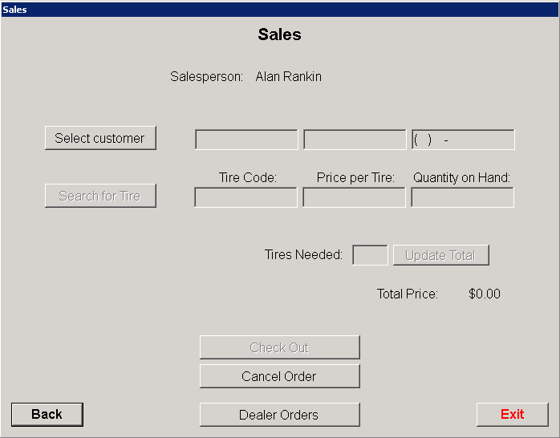

**(Figure L)**

Once you go into the dealer orders form the same steps are followed as if you were filling out a customer order above. You create a new order then select your dealer, search and choose the tire, enter the quantity and update the total. Once that is done you simply push the “Save and Print Order” button.

1. **Reports**

Next is the Reports button, which managers and admins have access to (Figure M). Here all you need to do is push the button of the report you want then wait for the report to generate. Once the report has generated you can either view or print it depending on what you want to do.

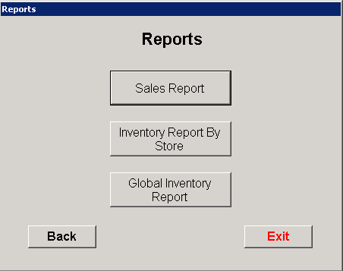

**(Figure M)**

1. **Tires**

The tires form (Figure N) is a form that can be accessed by admins only and allows you to add, modify, and delete tires. In this form you can search by tire code, manufacture, description, and tire size then modify or delete those tires. The add function allows you the ability to add new manufacture and tire types as needed.

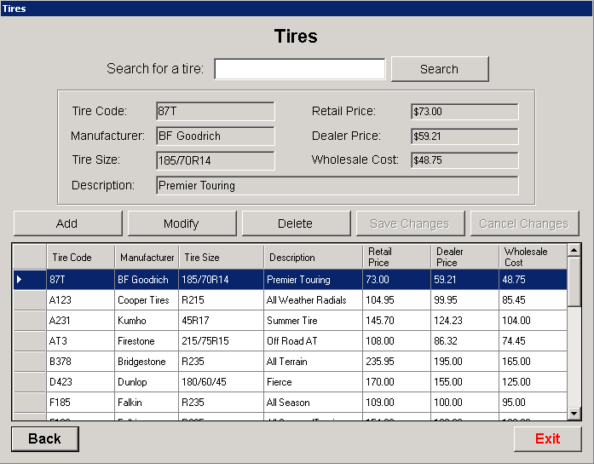

**(Figure N)**

1. **Stores**

The stores form (Figure O) which is admin access only is much like the tires forms with the exception of the ability to search. Since there are so few stores at the moment you view all the stores on one page and simply scroll up and down through the stores.

You do have the ability to add, modify or delete stores as needed and all pertinent information about the stores is viewable here as well.

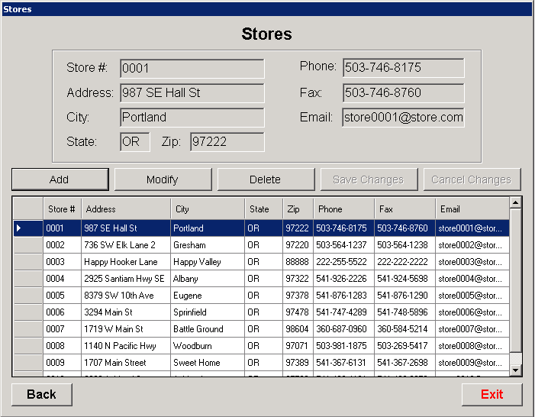

**(Figure O)**

1. **Employees**

The employee form (Figure P) gives you the ability to search, add, modify, or delete employees. It does provide a grid view and the choice between scrolling or searching for particular employees. It also provides the admin the ability to view user names and passwords for the expressed purpose of providing that info to employees if lost or forgotten.

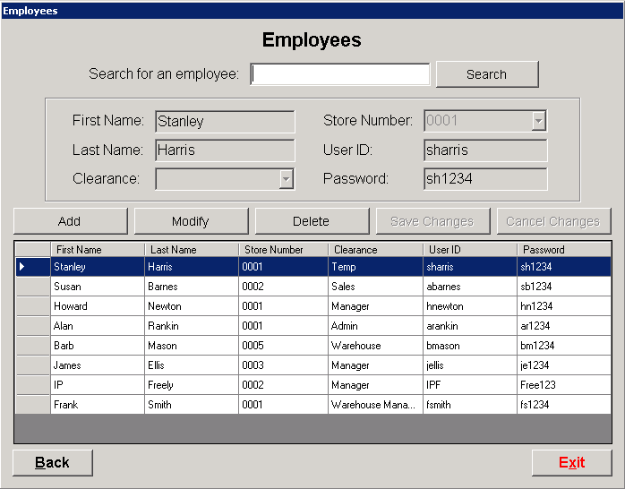

**(Figure P)**

1. **Purchase Orders**

The final form is Purchase Orders (Figure Q) where you have the ability to view open orders, create new purchase orders and receive the orders (warehouse managers). If you have admin access you will have the ability to access all aspects of this form, please see figures Q, R and S.

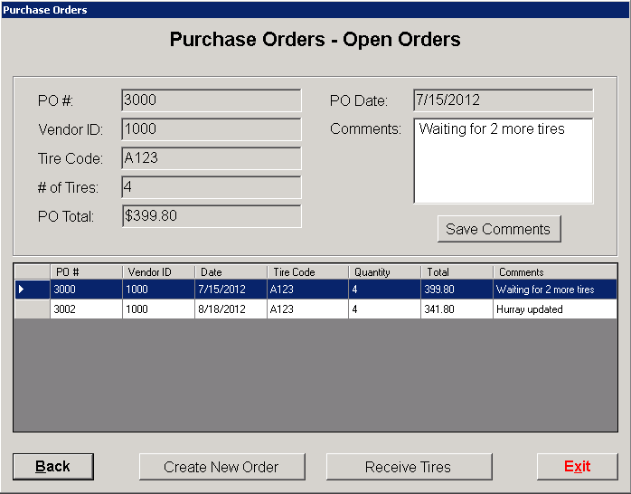

**(Figure Q)**

Once you press the “Create New Order” button you will be taken to the new order from (Figure R). Here you will populate all required fields and then given the option to print and save or cancel.

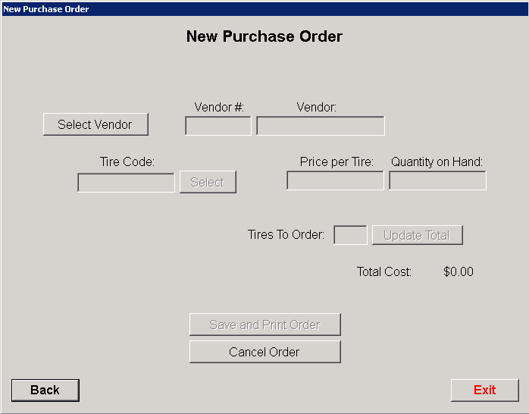

**(Figure R)**

In the instance that there is no warehouse manager on duty the people with admin access to the system will have the ability to receive tires (Figure S). In this form you have the ability to record the quantity of tires received then press OK. In the event that all tires were not received you will have the ability to add comments in the purchase order form on that line item.

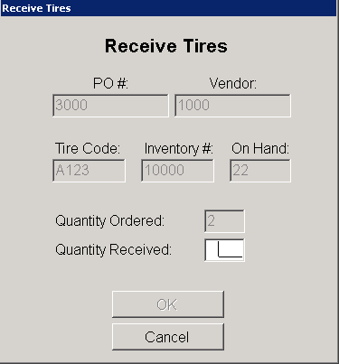

**(Figure S)**

The warehouse managers have access to the purchase order form as well with the exception of not being able to generate purchase orders.

## Technical Requirements

The following system requirements are required for the software to run efficiently:

**Central Server**

The main server will need to consist of an Intel or AMD based main processing unit with no less than 8 gig of memory, 60 gig of hard drive space, preferably in a RAID 1 or RAID 5 configuration, and a 10/100mg network connection. A standard mouse and keyboard as well as a LCD or other screen will also be required.

**Output Devices**

Due to the nature of some of the reports output by the system, a color printer at the main office where the Admin and Bookkeeper will reside is mandatory. These reports are used for re-order purposes.

**Required Software**

The server operating system will need to be Microsoft Windows 2008R2™ or better.

The database software required will be Microsoft SQL Server 2008R2™ or better.

A antivirus package of the owners choice is recommended.

A backup package and/or solution is highly recommended.

**Workstation Requirements**

All company workstations must have at least Windows XP™ or better with a minimum of 4g of workstation memory and at least 20g of free hard drive space. A mouse and keyboard with a screen of at least 14” are also required.

Printers will need to at least be black and white with as an option for non-server locations.

**Connectivity Requirements**

Each location will need to be connected back to the main office with a minimum of a 512kb data connection in order for the workstations to communicate with the central server.

The local network needs a minimum of 10/100 connectivity between workstations connected to a routing device to provide communications back to the central site.

## Database Specifications

